|  |  |  |  |  |  |
| --- | --- | --- | --- | --- | --- |
|  | Cells | Area/Cell  mm2 | Arrival Time  ns | Slack Time  ns | Power  mW |
| Adder | 21 | 69 | 2041.1 | 39958.9 | 149.911652 |
| Multiplier | 817 | 1290 | 3189.7 | 38810.3 | 2771.550049 |

# Adder Design

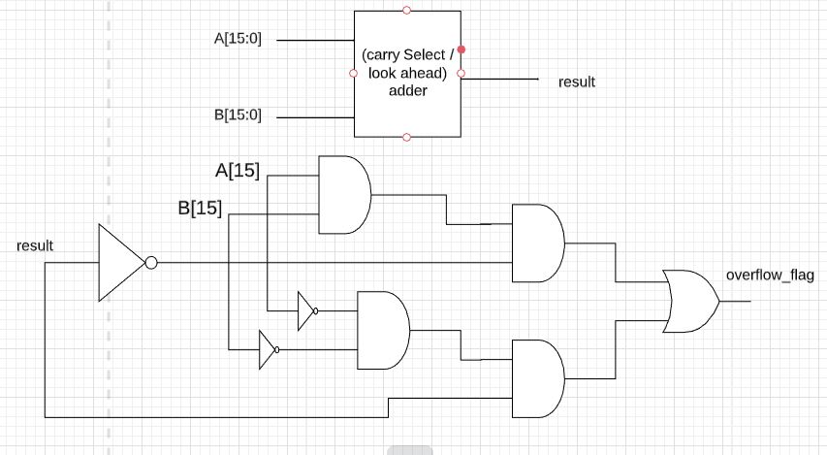

# Multiplier Design

